**1 & 2**

**West Seattle Aquarium Business Description:**

Welcome to West Seattle Aquarium, your premier destination for aquatic enthusiasts seeking an immersive and sustainable underwater experience. At West Seattle Aquarium, we go beyond being a mere fish store; we are a haven for those who share a passion for the mesmerizing world beneath the water's surface.

**What Sets Us Apart**

**Diverse Aquatic Selection:**

Dive into a curated collection of top-tier fish breeds, a vast array of common fresh, brackish, and saltwater fish, and aquatic accessories. Our commitment to quality ensures that each aquatic companion thrives and becomes a captivating centerpiece in your underwater haven.

**Expert Guidance:**

Our knowledgeable and dedicated staff, fueled by a shared love for aquatic life, is here to guide you through every aspect of fish care, tank maintenance, and aquatic decor. Trust us to provide expert advice tailored to your unique aquatic journey.

**Sustainable Practices:**

At West Seattle Aquarium, sustainability is at the core of our ethos. We meticulously manage operational costs, from water and electricity consumption to wholesale procurement, to provide you with eco-friendly options and promote responsible fishkeeping.

**Aquarium Design and Maintenance:**

Elevate your aquatic refuge or refuge with our professional aquarium setup and maintenance services. Whether you're a seasoned hobbyist or a beginner, we tailor our services to ensure your aquarium is not only visually stunning but also a thriving ecosystem for your fish.

**Community Engagement:**

Immerse yourself in a vibrant community of aquatic enthusiasts. From educational workshops to exclusive events, we foster connections among fellow hobbyists, creating a space for sharing experiences, tips, and love for finned companions.

**Our Mission**:

At West Seattle Aquarium, we aim to provide a sustainable and enriching aquatic experience. We prioritize environmental responsibility, community engagement, and customer satisfaction, making us your go-to destination for all your fishkeeping needs.

**Database Mission Statement:**

At West Seattle Aquarium, our database is pivotal in achieving our mission of providing a comprehensive and sustainable aquatic experience for both enthusiasts and their aquatic companions. We harness advanced technology to optimize operational efficiency, control costs, and foster a vibrant community within the realm of aquatic enthusiasts.

**Primary Purpose:**

The primary purpose of our database is to serve as a strategic tool for managing operational costs. By centralizing information on water and electricity consumption, wholesale costs of fish, and supplies, and equipment expenditures, we aim to make informed decisions that positively impact our bottom line while delivering exceptional value to our customers.

**Overarching Goals:**

**Cost Control and Efficiency:**

Utilize the database to meticulously track and analyze operational costs, including water and electricity usage, salt consumption, wholesale procurement costs, and numerous other costs. This empowers us to identify cost-saving opportunities, implement efficient resource management practices, and maintain competitive customer pricing.

**Inventory Optimization:**

Streamline inventory management through the database, ensuring optimal stock levels of fish and equipment. This not only reduces carrying costs but also minimizes the risk of overstocking or stockouts, contributing to a lean and efficient operation.

**Energy Conservation:**

Implement data-driven insights from the database to enhance energy conservation efforts. By monitoring and analyzing energy consumption patterns, we strive to adopt sustainable practices that reduce our environmental footprint while keeping operational costs in check.

**Supplier Relationship Management:**

Leverage the database to strengthen supplier relationships and negotiate favorable terms for fish and equipment procurement. This strategic approach allows us to secure competitive wholesale prices, improving our cost-effectiveness.

**Community Sustainability:**

Engage with the aquatic enthusiast community through the database, sharing insights on sustainable practices, cost-effective aquarium maintenance tips, and exclusive offers. Our goal is to create a community that not only shares a passion for aquatic life but also values sustainability and cost-conscious practices.

At West Seattle Aquarium, our database is a dynamic tool that aligns with our commitment to cost-effectiveness, sustainability, and community engagement. By effectively managing operational costs, we ensure the longevity of our business while delivering a delightful and affordable experience for aquarium enthusiasts.

**Mission Objective for Database Management:**

In alignment with our mission to optimize operational efficiency and control costs through our database at West Seattle Aquarium, we establish the following companion mission objective. This objective aims to ensure that our database becomes a dynamic and strategic asset, continuously evolving to meet the evolving needs of our aquatic community.

Objective: Harnessing the Power of Data for Sustainable Growth

Sub-Objectives:

Database Optimization: Regularly assess and enhance the database infrastructure to ensure optimal performance, scalability, and responsiveness. Implement updates and improvements that align with industry best practices and emerging technologies.

Integration of Cost Metrics: Expand the functionality of the database to seamlessly integrate and analyze additional cost-related metrics. This includes further refinement of data tracking for water and electricity consumption, salt usage, and equipment expenditures, providing a comprehensive view of operational costs.

Predictive Analytics: Implement predictive analytics models within the database to anticipate trends in operational costs. By leveraging historical data and market insights, we aim to proactively identify potential cost fluctuations, enabling preemptive cost-saving measures.

User-Friendly Interface: Continuously improve the user interface and accessibility of the database. Empower our team with an intuitive platform that facilitates efficient data entry, retrieval, and analysis, enhancing the overall usability of the system.

Security and Compliance: Prioritize data security and compliance within the database architecture. Implement robust measures to protect sensitive information, ensure compliance with data protection regulations, and foster trust among our customers, suppliers, and stakeholders.

Training and Capacity Building: Invest in ongoing training programs for our team to enhance their proficiency in utilizing the database effectively. Foster a culture of data literacy, empowering employees to leverage the database for strategic decision-making aligned with our mission.

Scalability Planning: Anticipate the future growth of West Seattle Aquarium and plan for the scalability of the database infrastructure. Ensure that the database can accommodate increased data volume, diverse data types, and evolving business needs without compromising performance.

This companion mission objective for database management serves as a roadmap for continuous improvement, ensuring that our database remains at the forefront of our cost-effective and sustainable initiatives. Through this objective, we aim to leverage the full potential of data to drive innovation, make informed decisions, and propel West Seattle Aquarium toward sustainable growth and success.

**Raw Data for #3  
  
Costs on an Annual Basis**

**Wholesale Costs:**

Purchase of fish and aquatic species from wholesalers

Individual fish #’s sold/yr

Type one – .49 0

Type two – 1.99 0

Type three – 3.99 567

More expensive (average) -19.99 252

By Bag of fish – (2 to 100 fish)

Type one – 19.99 699

Type two – 28.99 522

Type three – 45.99 375

More expensive (average) -99.99 42

**Procurement of aquarium supplies, equipment, and decorations**

**Ave price per item type**

Supplies (food, gravel, etc) 12.99 1,839

Equipment (tanks, filters, etc) 38.95 895

Decorations 17.94 4,067

**Operational Costs:**

Rent or lease for the store premises 45,466

Utilities (electricity, water, and gas) 36,324

Internet and phone services 2,896

Insurance (property, liability, and potentially business interruption insurance) 3,495

Licensing and permits 1,487

**Employee Expenses:**

Salaries and wages for store staff 206,000

Payroll taxes 38,000

Employee benefits, such as health insurance and retirement contributions 42,000

Training and development programs 2,777

**Aquarium Maintenance:**

Water treatment chemicals 4,982

Aquarium cleaning supplies 5,213

Replacement parts for aquarium equipment (filters, pumps, heaters, etc.) 2,748

**Inventory Costs:**

Cost of fish and aquatic species

Cost of aquarium supplies, equipment, and decorations

Packaging materials for products

**Marketing and Advertising:**

Advertising costs for promoting the fish store

Printing promotional materials

Online marketing expenses (website maintenance, social media advertising)

**Point-of-Sale System:**

Purchase and maintenance of a point-of-sale (POS) system 1,006

Transaction fees for credit card processing

**Transportation:**

Delivery costs for fish and supplies 3,286

Vehicle maintenance for transportation purposes 2,834

**Environmental Controls:**

Heating and cooling systems for maintaining appropriate temperatures 3,825

Backup power systems (generators or battery backups) 0

**Aquarium Display and Design:**

Cost of setting up and maintaining attractive aquarium displays 3,899

Investment in aesthetic elements to enhance customer experience 798

**Community Engagement:**

Costs associated with hosting events and workshops

Community outreach and sponsorship activities

**Security:**

Security systems (alarms, cameras)

Security personnel or services

**Waste Management:**

Disposal costs for waste generated in the store

Recycling programs

**Technology and Software:**

Point-of-sale software and licenses

Inventory management software

Customer relationship management (CRM) software

**Professional Services:**

Accounting and bookkeeping fees

Legal services

**ER Diagram:**

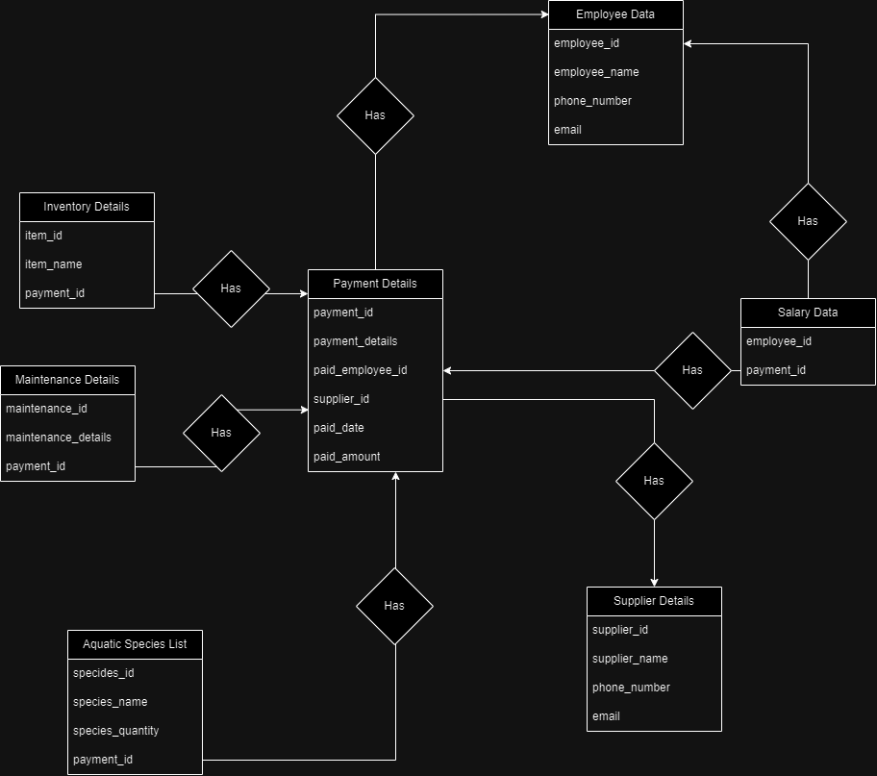

**Assumptions:**

1. Items will be purchased separately to manage purchase data easily.

2. Any of the purchases will not put tax or any other additional fees into consideration.

3. It will assume items or maintenance details will have the same description for the same type of item or description. It can also be done with an individual table taking care of items or maintenance having unique IDs based on their types but would make it a bit harder to read.

4. In Payment Details, paid_employee_id and supplier_id is set to NULL as default. It will stay that way unless the added data requires those data to be set as specific employee or supplier ID.

**Additional Notes:**

Normally, the payment_id values in different tables would be written in foreign keys to specify they are referencing the ID value from PaymentDetails table. However, due to user access issues in phpMyAdmin, they are using integer values instead of foreign keys. Thus, the foreign key reference lines are commented out in order to use the database and tables in phpMyAdmin.